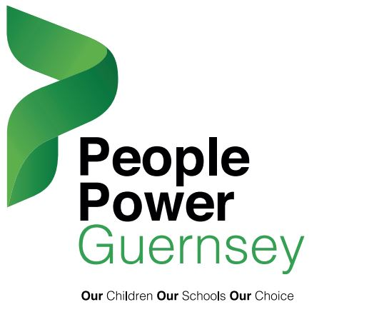
OPEN LETTER TO ALL DEPUTIES AND MEDIA
24 February 2020
Thousands of people depend on your one vote
As you will know this week is vastly important and your vote in the States is likely to make a difference to Education in Guernsey for many years to come. We are really hoping it will be a vote to pause and review. In many ways such a vote will mean that secondary education will be delayed for a minimum amount of time. Any vote to continue with the one school, two sites process is going to delay education reforms further as this will inevitably become an election issue in June.
People Power Guernsey came together in January 2020, a group of strangers brought together by a common goal – to stop this two-school model and pause the transition for the sake or our children and generations to come. We had all been vocal individually but as a group vowed to give like minded individuals a voice. We have since had almost 6,000 people sign a petition against the two-school model and arranged a protest march in less than a week, which was attended by thousands of concerned individuals.
We have been approached and thanked by many for giving them a voice, indeed many teachers have also sent us individual messages stating they were unable to come to the march but were grateful for what we are doing, many have given us questions to ask.
We have had individuals message asking what they can do to help us and others in tears ‘gutted’ as to what is on the table and how they may now have to look at moving or financially stretching themselves to ensure their children have the educational opportunities they believe they deserve.
We have watched with interest as many amendments to the current requete have been placed. Whilst some may offer the people we represent hope, we are concerned that none of them offer a halt to the current plans being pushed through. Two of the amendments aim to overturn the requete in its entirety and continue with the two-schools process with promises to look at further sites. We believe none of these go far enough and real solutions will not be investigated unless the current process is paused.
The people we represent wish for the one school two sites transition to be put on hold. There are too many uncertainties, too much back tracking and too much afterthought to plans to have any confidence in it as it stands.
We are asking you as a deputy to vote for the requete unamended as it is the only way to stop the process at this time and save generations in Guernsey from schools not fit for purpose and not necessary in our island.

Yours sincerely,
People Power Guernsey
peoplepowerguernsey@gmail.com

About People Power Guernsey
People Power Guernsey is made up of concerned individuals who are passionate about giving everyone who is against the current ESC proposals a voice by setting up various events, displaying green ribbon and hosting a petition. They are not suggesting what model is most preferable or identifying which parts of the proposal they are against (ie traffic, volume of students, lack of space etc) Their only objective is to raise awareness of the level of public concern and show support for the Requête to delay the current ESC proposals until after the election. They would like deputies listen to their electorate including the skilled teaching professionals who have already spoken out.

