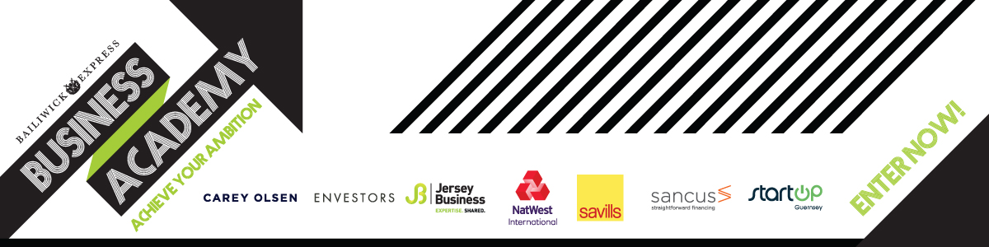

START UP APPLICATION

By answering the questions below, you will help us to understand a little bit about you, your business idea and where you are with regard to planning and researching your business. Please try to keep answer to under 200 words.

Please complete this form and return it to businessacademy@bailiwickexpress.com and then we will be in touch. All the information you share with us will be held in the strictest confidence under our Business Proposal Submission Agreement.

Your details:

Name:
Phone number:
Email:
Your residential status?
How did you hear about us?

About your business idea - Please try to answer each of the following questions in as much detail as possible.

(Proposed) Business Name:

What products or services will you sell?

Who is going to buy them? (Think about your most important customer)

How will you stand out? (Describe the main benefit to your customer?)

What will you charge?

Have you created a sales plan or financial forecast that shows revenue (sales) by month for your first year and the cost price of those sales ?

How much profit will you need to make to break even (cover your costs)?

What will you do to help customers find out about your business?

Who are your competitors and how do you compare to them?

When (ideally) do you intend to start trading?

Will you need to find premises or buy equipment?

How much cash does the business need to start up and where will you find this?

Do you need to employ staff?

What experience and skills do you have to run this business?

How much do you need to earn from the business? (Will this be your main income?)

What are the main challenges you will face over the next 12 months?

Please be aware this information will be shared with the panel. For full terms and conditions please visit www.bailiwickexpress.com/businessacademy

Before you share your idea with us, you must confirm that you have read and agree to our Business Proposal Submission Agreement which can be found at www.bailiwickexpress.com/businessacademy.

Please sign below to confirm you agree:

If you would also like your application reviewed by Natwest International for a business loan please tick this box 

